Requirements for each problem:
- Numbers you were asked for,
- The predictions you made before measuring,
- And two or three sentences of interpretation
- Code listings do not belong

Problem 1. A Piece That Cannot Mate

Prediction: I predict that there will be zero king and knight checkmate positions. I also predict that the bishop and king will have around three times the number of stalemate positions as the knight and king.

Summary: Knights can only move to opposite-colored squares, leaving at least two escape routes for the opponent. The two escape routes will always be in different directions. The king cannot block both escape routes meaning the best a king and knight can do is stalemate. The bishop having three times the stalemates positions come from thinking about the king trapped in a corner. The bishop can be in any position along the diagonal to enforce checkmate.

Piece | Legal Moves | W to move | B to move | Mates | Stalemates
Rook | 399,112 | 175,168 | 223,944 | 216 | 68
Queen | 368,452 | 144,508 | 223,944 | 364 | 872
Knight | 429,440 | 205,496 | 223,944 | 0 | 40
Bishop | 417,228 | 193,284 | 223,944 | 0 | 136

Problem 2. Symmetry

Prediction: I predict all eight board symmetries will give the same result, preserving both legality and distance to mate. I also predict that the reduced table would use much less memory, but not quite eight times faster.

Summary: The symmetry checks that rotating or reflecting a panwless position does not change its result. The reduced table saves memory because only one position from each orbit is stored, but retrograde solving still requires a large amount of work generating and processing positions, so the time saved is smaller than the memory saved. A failure in the symmetry test would suggest a bug in the way positions were represented or movement.

Pawns: The surviving symmetry is any reflection across the center vertical line. The maximum saving would only be about a factor of two.

Item | Result
Index Slots | 524,288
Legality Comparisons | 4,194,304
DTM Comparisons | 3,192,896
Unique Legal State Orbits | 50,015

Problem 3. The Fifty-Move Rule

Summary: Distance to mate measures how many plies remain before checkmate under optimal play. Distance to zeroing measures how many plies remain before a pawn move or capture resets the half move clock, with terminal mate handled separately. In king and rook versus king, there are no pawns. The only possible capture is black capturing white’s rook, which results in a draw. Thus, under optimal play, no zeroing move occurs before mate. I would recommend the 100-ply result to a chess player, because the 50-move rule uses 100 plies total without a pawn move or capture.

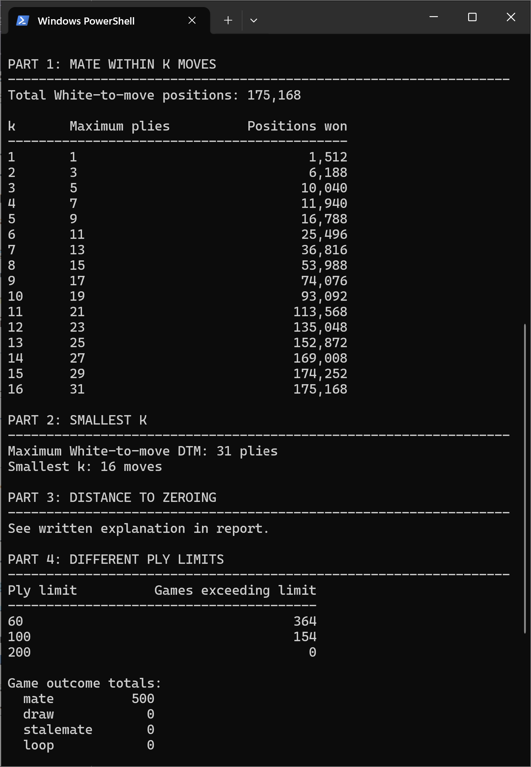

Problem 4. A Better Evaluation

Predictions: King opposition feature shows positions where the kings are separated by two squares on the same file or rank. I predict this feature will help identify positions where white’s king can restrict black’s movement. Rook protected feature identifies positions where white’s king protects its rook. I predict this feature will improve the evaluation by rewarding safer rook positions and reducing moves that allow black to capture the rook. I expect these to reduce RMS errors.

I also predict that the least-squared evaluation will have a lower RMS error and a higher correlation since weights are optimized against the exact DTM values. Finally, I predict that the fitted evaluation will also improve accuracy.

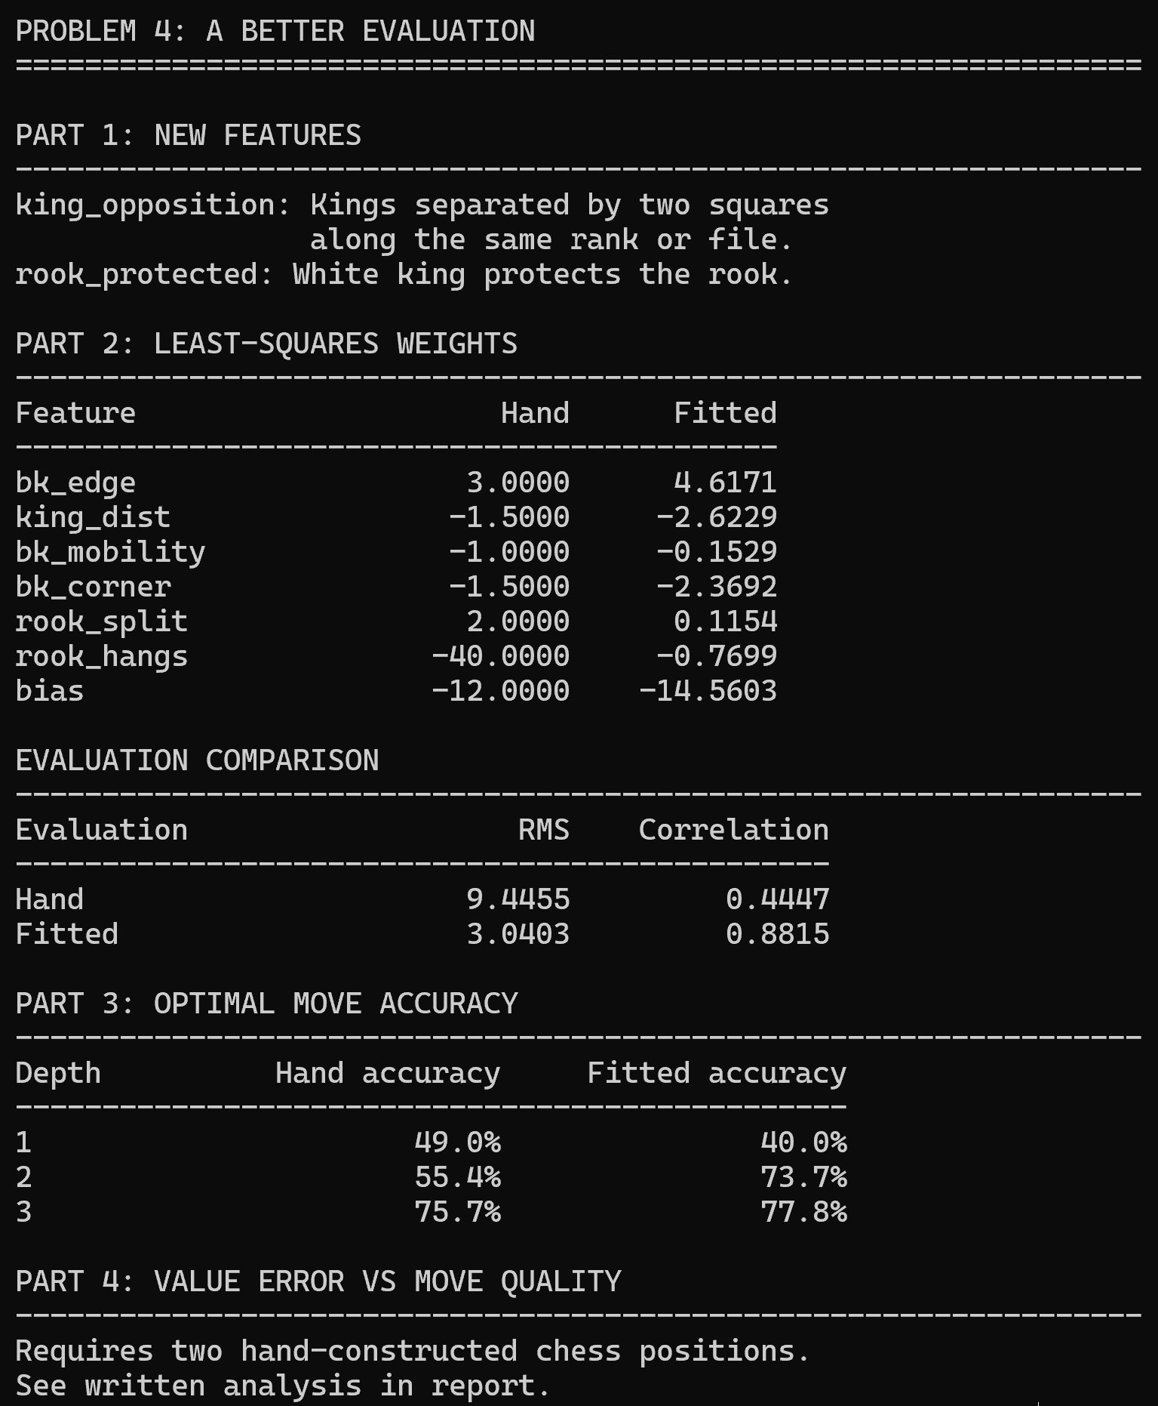

Problem 5. Making the Search Cheaper

Predictions: I predict that iterative deepening will improve root move ordering, and it should reduce the work performed by the final search. Since it repeats searches at shallower depths, its total node count may not be lower than ordinary search. I predict that the transposition table will reduce repeated evaluations by reusing results from previously visited states. I expect all correct searchers to return the same value as plain minimax. I predict that the deliberately buggy searcher will produce incorrect values for some positions.

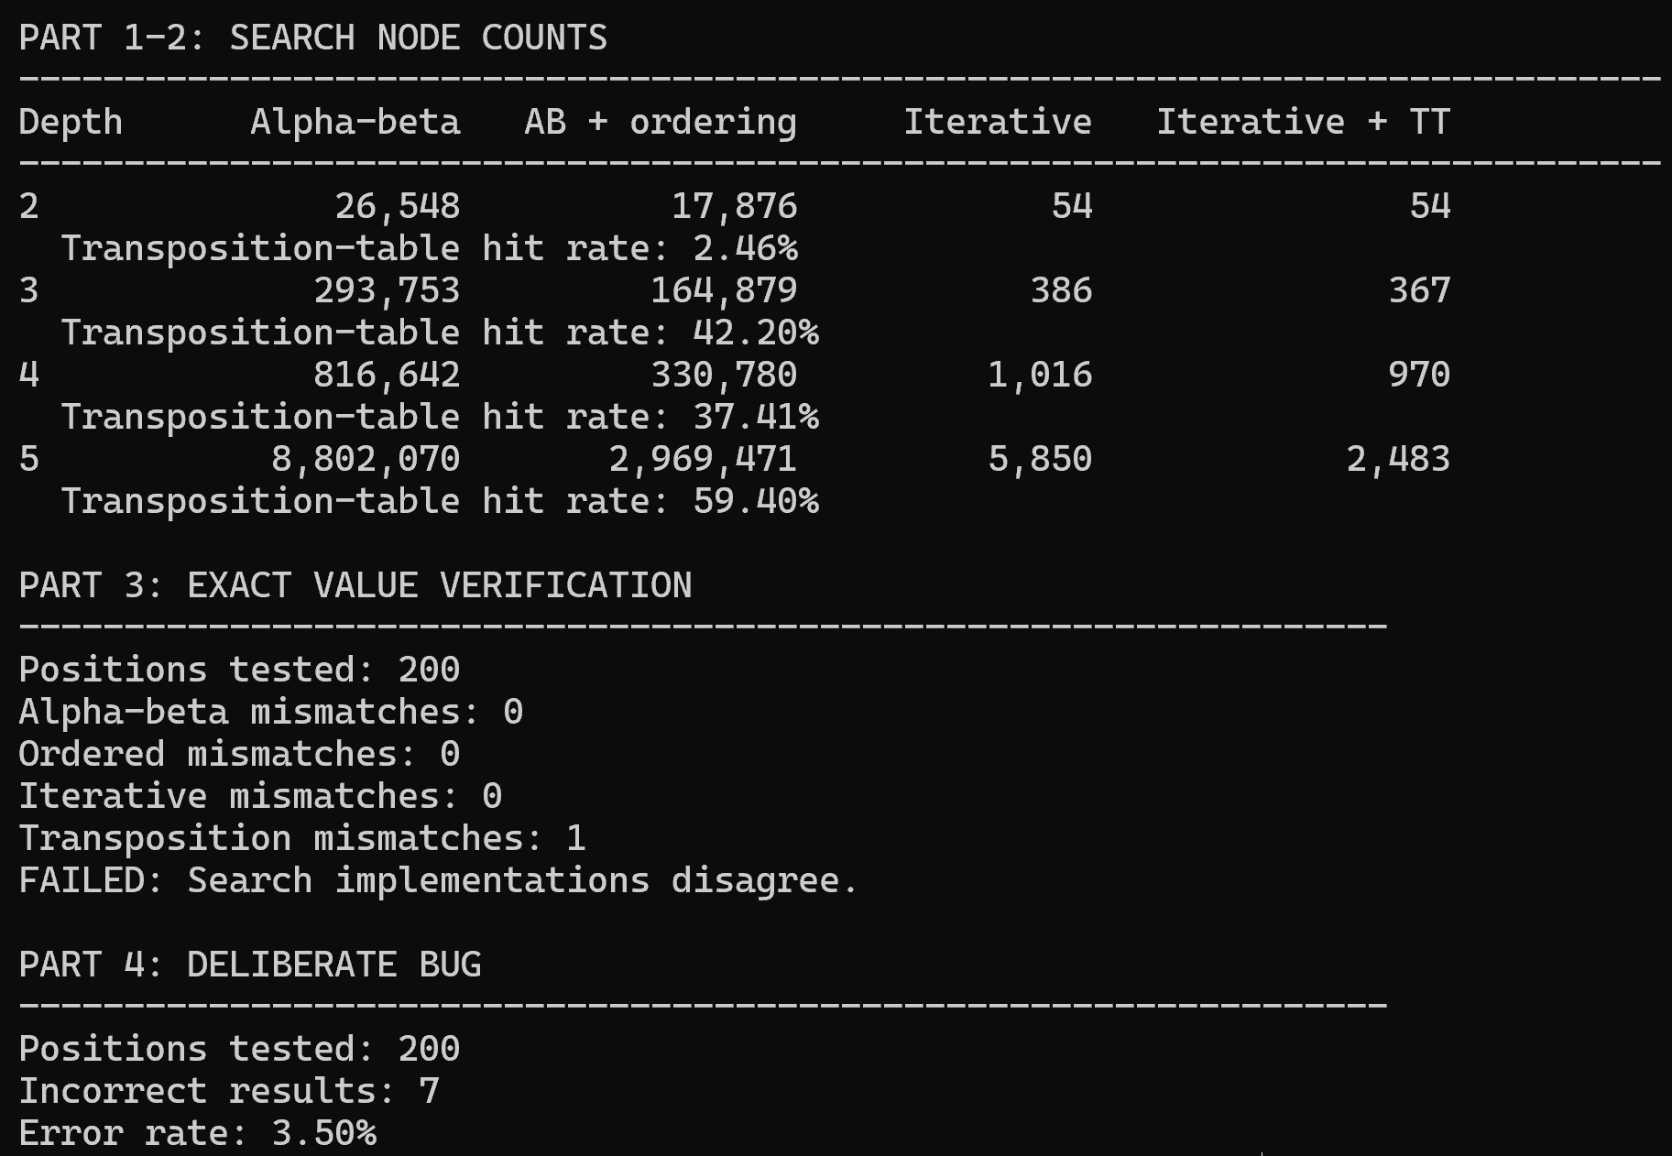

Problem 6. Self-Play, Repeated

Predictions: The learned weights and playing performance will be different across seeds since the algorithm randomly draws a positions and exploration moves. The learning rate will affect training stability. Larger values will produce bigger variations. Finally, the hanging rook weight will be inconsistent across seeds because dangerous positions may not receive enough useful training feedback.

Problem 7. Where the Two Halves Meet

A chess engine must balance efficiency with accuracy. Two approaches are endgame tablebases and learned evaluation functions. Tablebases determine the theoretical outcome of positions with limited pieces, while learned evaluations estimate the quality of positions that are too complicated to solve. Combining both approaches gives the best results.

- What tablebases provide

Tablebases eliminate uncertainty. In problem one, the king and rook versus king table contained 399,112 legal positions. The table provides the distance to mate for winning positions, rather than an estimate of quality. Heuristic evaluation differs. In problem 4, the hand-written evaluation reported RMS error of 9.45 plies and correlation of 0.445. At search depth 1, the program selected an optimal move 49% of the time, meaning the program did not identify the best move. With the help of a tablebase, uncertainties with heuristic can be covered.

- The fifty-move rule changes the meaning of a win

Tablebases provide correct outcomes, but those outcomes must be interpreted using the rules of chess. In king and rook versus king, there are no pawn moves, and a capture of the rook results in a draw. Consequently, a winning sequence cannot reset the half move clock before checkmate. A winning position can become a draw if a player takes too long.

Problem 3 shows this distinction by restricting the number of moves available to deliver checkmate. The table identifies the shortest forced mate, while the fifty-move rule adds another constraint. The day six results showed that 154 of 500 games required more than 100 plies to deliver checkmate. In normal chess, these games would be considered a draw before checkmate can be reached.
The additional results from the program were 364, 60-ply games and 0, 200-ply games exceeding the fifty-move constraint. This means a chess engine must consider more than whether a position is winning. It must also determine whether the win can be completed in time. Modern engines benefit from tablebase information.

- Where the engine should switch between methods

I would place the transitions between learned evaluation and tablebase lookup at the boundary of the tablebase. For positions containing mor pieces than the tablebase, the engine should use search and learned evaluations. Once the game reaches a position covered by the tablebase, the engine should replace the approximate evaluation with the exact result. This ensures correct information about the outcome and allows the engine to choose moves consistent with the optimal endgame.

Problem 5 shows at depth 4, alpha-beta reduced 4,769,474 nodes across 400 positions to 816,642 nodes, and moves ordering reduced it further to 330,780 nodes. These improvements make depeer search more practical, but they do not eliminate evaluation error.

- Why the seven-man boundary exists

The boundary is a result of complexity and storage requirements, not a limitation of theory. As pieces are added to the board, the number of possible arrangements increases dramatically. The table must also distinguish legal positions, the side to move, and other game information. Storing computing and storage outcomes becomes expensive.

By exploiting symmetries in the chess board, as shown in problem two, costs can be reduced. The assignment shows 28,056 placement orbits compared with 399,112 legal rook endgame positions. Symmetry can reduce redundancies, but it canot eliminate the work to generate moves and shows exact results. Seven piece tablebases represent nearly the limit of what we can currently do. Extending coverage to eight pieces is possible, but just becomes more expensive. Thus, the boundary reflects current available computational resources.

- Conclusion

Tablebases and learned evaluations solve different parts of the same problem. Learned evaluations make it possible to search large game trees, but their estimates can be inaccurate and may lead to poor moves. Exact tablebases provide perfect play for positions small enough to solve completely. My results show that engine architecture that uses learned evaluation and tablebase information results in the flexibility needed for a real chess game.

